**Set up VPN on Mac (Sequoia 15.0.0 onward)**



1. On the Finder menu, click on the Apple icon.

2. In the drop-down menu, click on System Settings….

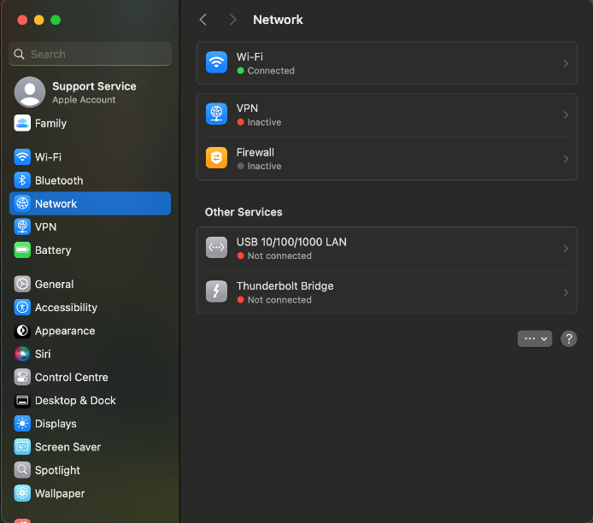 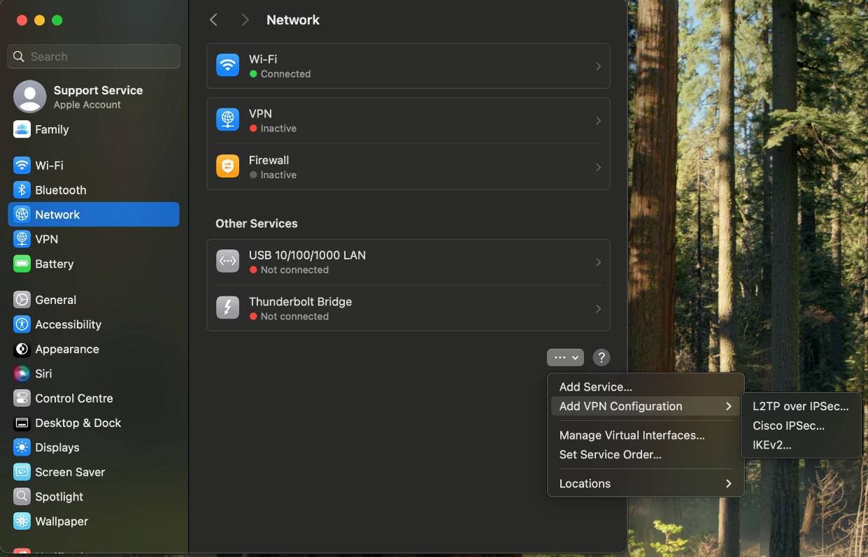

3. Click on Network.

4. Click on the ellipses > Add VPN Configuration > select “Cisco IPSec…”

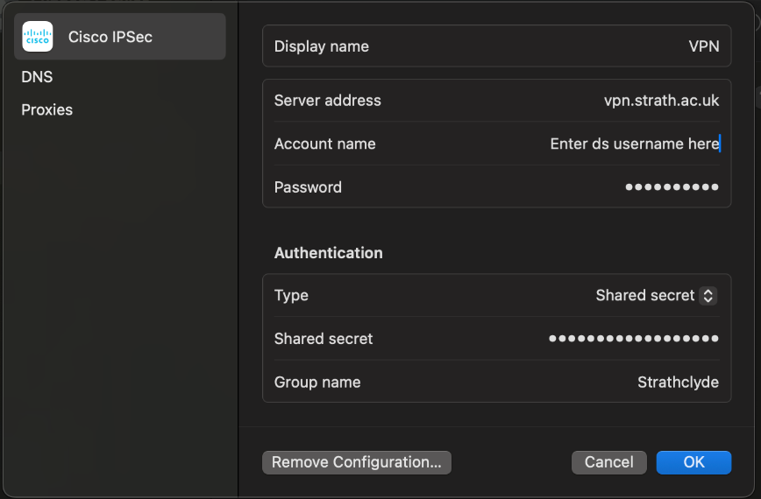

5. Enter the following details into the input fields:

Server address – vpn.strath.ac.uk

Account name – **this will be your ds username**

Password – **this will be your password**

Shared secret – johnandersoncampus

Group name - Strathclyde

6. Enter your ds username and password and hit ok. You should now be able to toggle the VPN on in the Network page

Was this information helpful?

**CONTACT US**

**Email**: help@strath.ac.uk **Call**: 0141 548 4444

YOUR

LIBRARY

**YOUR LEARNING…**