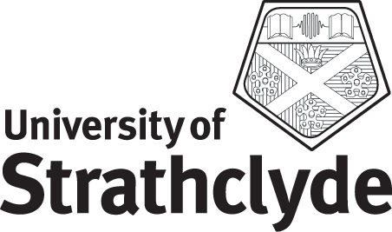

Programme Specification

Programme title and name of final award:

UCAS Code:
Awarding institution: University of Strathclyde

Teaching institution(s): University of Strathclyde

Credit and level definition of final award:

Credit and level definition(s) of any intermediate exit points:

Reference points for academic standards (i.e. subject benchmark statements):

Professional, statutory or regulatory body accreditation:

Aims of the programme:

Learning outcomes of the programme (knowledge and understanding, skills and other attributes):

Normal duration of the programme:

Structure of the programme (including mode of study):

Methods of assessment and learning and teaching approaches:

Entry requirements including opportunities for credit transfer into the Programme (i.e. from HNC, HND):

Pointers to further study-progression routes and any major opportunities for credit transfer out of the programme:

Further information:

Date of approval by the Faculty Board of Study:

