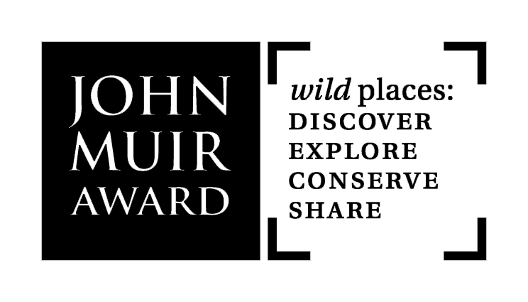
John Muir Award Proposal Form
Outline your activity and describe how you will meet
the Four John Muir Award Challenges

This Proposal Form is an aid to your planning and delivery of a John Muir Award, at Discovery,
Explorer or Conserver Level. It enables Award staff to offer support and advice, and helps ensure that your Proposal will lead to successful completion of Awards.

Responsibility for ensuring adequate health & safety, legal and insurance arrangements lies with the group/organisation (or individual/ family) that is setting up activity towards achieving John Muir Awards.

Refer to Resources page at johnmuiraward.org for Information Handbook and Award Criteria.

Send a copy of your Proposal Form to your appropriate regional Award contact at least 2 weeks before starting. If not known, please click on Contacts at johnmuiraward.org. Alternatively, send to info@johnmuiraward.org, or John Muir Award, 41 Commercial Street, Edinburgh EH6 6JD

contact person |  |  | date
group/organisation
or individual/family
address | postcode
phone |  | e-mail
mobile |  | web

Are any organisations or partners helping towards this Award?

Summary of Award Proposal | Select Award level | Discovery / Explorer / Conserver
Outline the main aims and themes of what you plan to do. What is/are your main reason/s for using the John Muir Award?

Group background
Include details such as: who the group is, age ranges, group size, any referral process, other relevant points.

Start date |  | Finish date

Estimated time commitment | E.g. number of days, hours spent per week, residential length

Is any evaluation taking place for this activity/work/project?

How many people are participating? |  | participants |  | leaders/staff

Record books: | 1: Download print-ready PDF from website Resources page OR
 | 2: Request  specify number |  | hard copies (1 per participant/leader)

Outline how you plan for all individuals involved to meet the Four John Muir Award Challenges.
See johnmuiraward.org for information, resources, ideas and case studies. Consider how you will introduce John Muir into your Award activity.

Discover a wild place  Where/what is your wild place (or places)?  This can be school grounds, local park, beach, woods, river, mountain or national park…  Briefly:  ACTIVITIES  PLACE  PUT BACK  SHARE  Where will your activity take place? (Note all the places you will visit).  What is the natural character of your chosen place(s)?  What makes it special for you/your group?  Why is it a suitable place for your Award activity? |  |  | Explore it  Tell us what you’ll do to increase your awareness and understanding. How will you experience, enjoy and find out more about your wild place(s)?  You might:  Visit it at different times of day and night, in different seasons, alone or with others.  Travel extensively – walk, camp, bike, canoe.  Sit, look, listen - engage senses.  Identify and find out more about landscapes, habitats and living things (biodiversity), and how they connect.  Make maps. Take photographs. Research local geology, natural and cultural history.
Conserve it  How will you care for your wild place(s), take some personal responsibility, make a difference, put something back?  Take practical action for nature - wildlife or pollution surveys, litter picks and audits, tree or shrub planting, grow plants for wildlife or clear invasive plants, create or monitor habitats…  Campaign and inform others to highlight an environmental issue or help protect a wild place.  Apply minimum impact approaches to your activity. |  |  | Share your experiences  Tell others about what you’ve done – experiences, achievements, feelings, what’s been learned. Celebrate!  Reflect, review and discuss your adventures and experiences in wild places – do this during as well as after, informally or more formally.  You might:  Make a display of photos, drawings, stories, poems, artwork.  Make a group diary – as a book, wall display or film.  Organise a presentation.  Lead a guided walk around your wild place(s).  Use newsletters, websites and social media.

