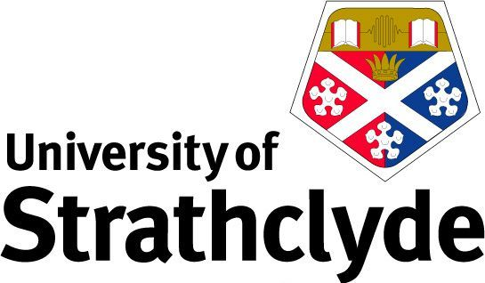

**The Person in Scotland and the World: 40 Years of Private Law Reform**

**A seminar to honour the contribution to scholarship of Professor Kenneth McK. Norrie**

Friday 15 November 2024

University of Strathclyde Technology & Innovation Centre, 99 George St. Glasgow. G1 1RD

|  |  |
| --- | --- |
| 9:00 – 9:30am | Registration and coffee |
| 9:30 – 9:45am | Welcome  The Right Hon Lady Wise (Chair)  Professor Adelyn Wilson, Head of the Law School, University of Strathclyde |
| 9:45 – 11:00am | *Shaping the Law: Professor Norrie’s contribution to law reform in Scotland*  Professor Gillian Black, Scottish Law Commission & University of Edinburgh  *What would a progressive abortion law look like in Scotland?*   Dr Lynsey Mitchell, University of Strathclyde  *Disputed information in a children’s hearing: Is there still a defence of O v Rae?*  Dr Alyson Evans, University of Strathclyde |
| 11:00 – 11:15am | BREAK |
| 11:15 – 12:30pm | *An Age of Inconsistency: The legal capacity and responsibility of children and young people in Scotland*  Elaine E. Sutherland, Professor Emerita University of Stirling & Distinguished Professor Emerita Lewis and Clark Law School, Portland, Oregon  *Crossing Borders: Changing approaches to children’s views*  Janys M. Scott KC, Westwater Advocates  *The Incorporation of the UN Convention on the Rights of the Child in Scotland*  Bruce Adamson, previous Children and Young People’s Commissioner Scotland |

|  |  |
| --- | --- |
| 12:30 – 13:30pm | LUNCH |
| 13:30 – 14:45pm | *Trans Parenthood: “Factual Purposes” and “Legal Statuses”*  Dr Alan Brown, University of Glasgow  *Case-watching and trend-spotting: shifting habits of domestic abuse in Scots family law*  Professor Jane Mair, University of Glasgow  *Succession*  Dr Dot Reid, University of Glasgow |
| 14:45 – 15:00pm | BREAK |
| 15:00 – 16:15pm | *From ‘rough and ready’ to regulated? The case for adopting a children’s rights-based approach in childhood negligence proceedings*   Dr Lesley-Anne Barnes Macfarlane, University of Glasgow  *Reflecting on Romantic Romanisms: Divine Janus and the delict of ‘assault’*   Dr Jonathan Brown, University of Strathclyde  *Dignity and Delict*  Dr Stephen Bogle, University of Glasgow |
| 16:15 - 16:30pm | Chair’s Reflections & Close  The Right Hon Lady Wise |